

OO Analysis & Design Project 2025

SDH2-B Group 6
Ice Ybanez, Matas Orliukas

Table of Contents
Part A 3
Question 1 - Analysis Model Domain Model 3
Question 2 - System Sequence Diagram 4
Question 3 – Identify and List Operations Signatures 5
Question 4 i. Find the delivery address of an order 6
Question 4 ii. Find the status of an order 6
Question 4 iii. Find the journey time of a particular delivery schedule 7
Question 4 iv. Find the total cost of an order for a particular customer 7
Question 4 v. Find the current location of a driver who is out on a delivery of a customer order 8
Question 5 Design Model Design Class Diagram 9
Question 6 Design Model Design Class Diagram (extended) 10
Part B 11
Question 1 i. 11
Question 1 ii. 11
Question 1 iii. 12
Question 1 iv. 12
Question 2 13
Student Declarations 14
Ice Ybanez 14
Matas Orliukas 14

Part A

Question 1 - Analysis Model Domain Model
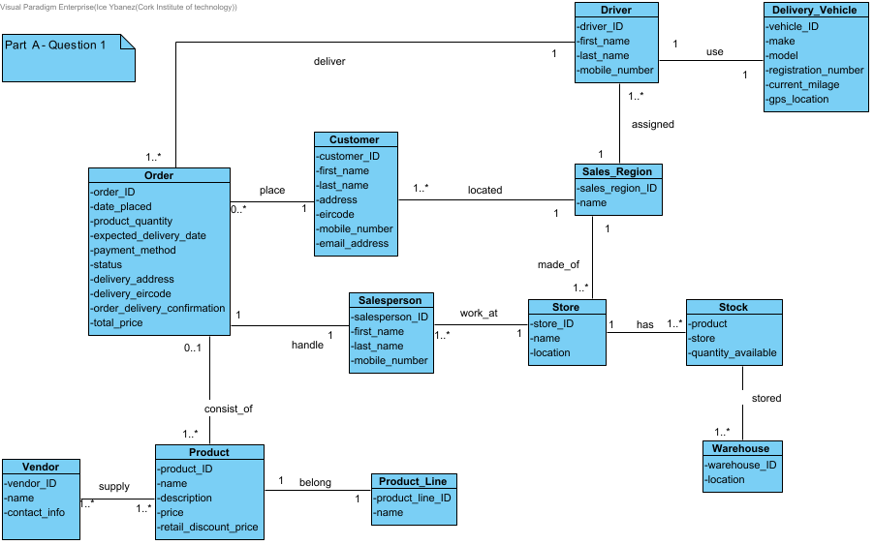

Question 2 - System Sequence Diagram

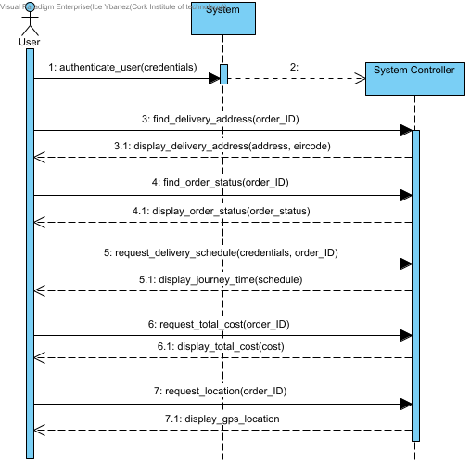

Question 3 – Identify and List Operations Signatures
i) authenticate_customer(credentials) - Customer
input_order(order_ID) - Customer
request_delivery_address(order_ID) - Customer
find_order_delivery_address(order_ID) - Order
display_delivery_address(address, eircode) - Order

ii) authenticate_customer(credentials) - Customer
input_order(order_ID) - Customer
request_order_status(order_ID) - Customer
find_order_status(order_ID) - Order
display_order_status(order_status) - Order

iii) authenticate_driver(credentials) - Driver
input_order(order_ID) - Driver
request_delivery_schedule(credentials, order_ID) - Driver
calculate_total_delivery_schedule(order_ID) - Order
display_journey_time(schedule) - Order

iv) authenticate_customer(credentials) - Customer
search_order(order_ID) - Customer
retrieve_order_info(order_ID) - Order
request_total_cost(order_ID) - Customer
calculate_product_cost(price, product_quantity) - Order
display_total_cost(cost) - Order

v) authenticate_user(credentials) - Customer
request_location(order_ID) - Customer
find_driver(order_ID) - Order
find_vehichle(driver_ID) - Driver
locate_gps(vehicle_ID) – Vehicle
display_gps_location(location) - Vehicle

Question 4 i. Find the delivery address of an order
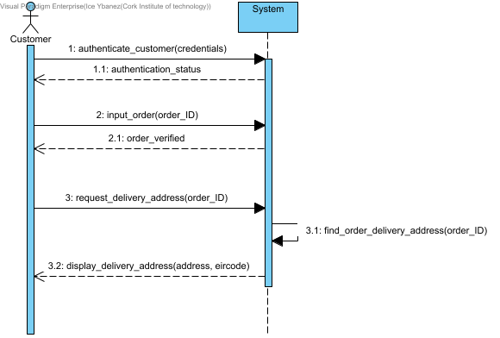

Question 4 ii. Find the status of an order
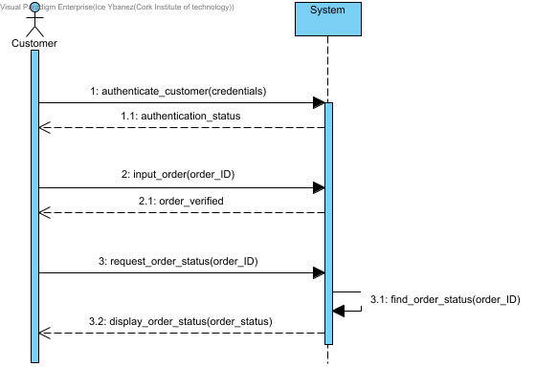

Question 4 iii. Find the journey time of a particular delivery schedule
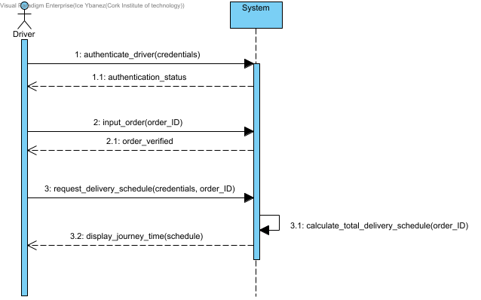

Question 4 iv. Find the total cost of an order for a particular customer
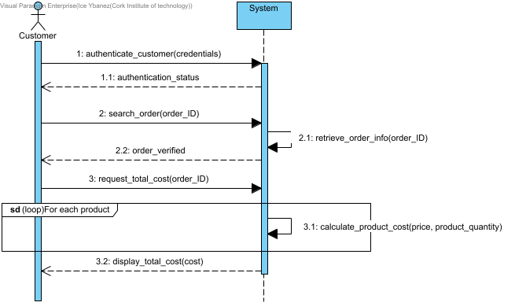

Question 4 v. Find the current location of a driver who is out on a delivery of a customer order
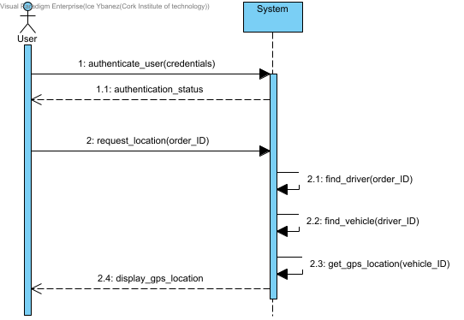

Question 5 Design Model Design Class Diagram
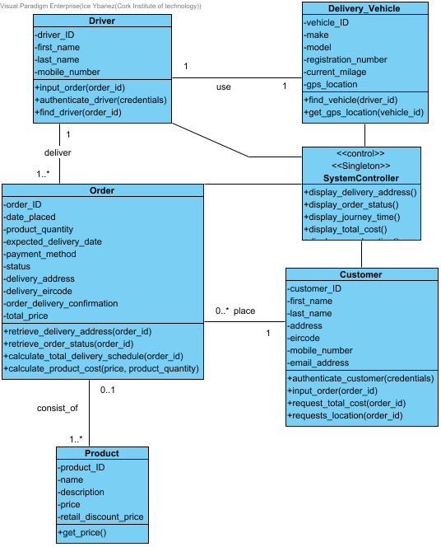

Question 6 Design Model Design Class Diagram (extended)

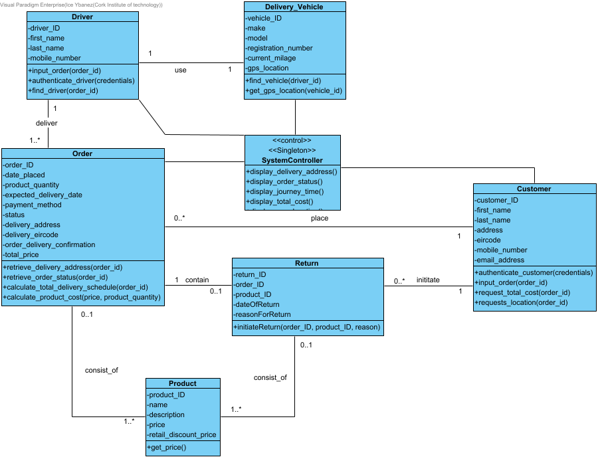

Part B

Question 1 i.

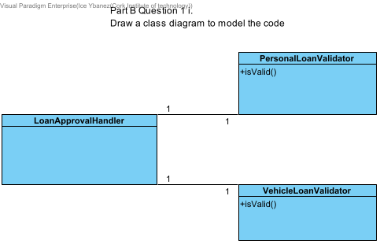

Question 1 ii.
The code violates the open closed principles because in the LoanApprovalHandler class, whenever a new type of loan needs to be supported, the class must be modified to add new approval methods for the new type of loan.
This modification of the LoanApprovalHandler class violates the open closed principle since software entities should be open for extension and closed for modification.

Question 1 iii.
public interface LoanValidator {
boolean isValid();
}

public class PersonalLoanValidator implements LoanValidator {
@Override
public boolean isValid() {
// Personal loan validation logic
}
}

public class VehicleLoanValidator implements LoanValidatorx {
@Override
public boolean isValid() {
// Vehicle loan validation logic
}
}

public class LoanApprovalHandler {
public void approveLoan(LoanValidator validator) {
if(validator.isValid()) {
// Process the loan
}
}
}

Question 1 iv.
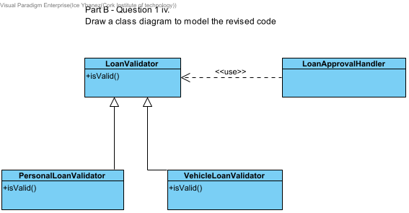

Question 2

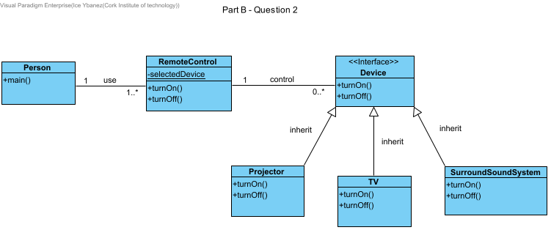

We have designed the class diagram in a way that the Person class interacts with the RemoteControl class to operate devices found in the main method of the Person class.

The RemoteControl class has a static method, selectedDevice, that allows the Person to choose a device and the turnOn and turnOff methods call the selected device’s methods.
This follows the open - closed principle.

The Device class is a common interface that all devices will implement. It also has turnOn and turnOff methods to be used in the RemoteControl class.
Since the Device class is an interface, it allows for more devices to be added in the home entertainment system without breaking the code because you only need to create a new class that implements the Device class for a new device to be created.

Finally, the Projector, TV and SurroundSoundSystem classes are classes that implement the Device class with each having their own specific implementation of the methods turnOn and turnOff.

Student Declarations

Ice Ybanez
Student declaration
I can confirm the following details:

Student ID/Registration number: ________R00176611_________
Name: _____Ice Ybanez______
Module Name: OO Analysis and Design Lab
Lecturer: Nasir Ahmad/ Vincent Emeakaroha
Due Date: April 27, 2025 @midnight

Matas Orliukas
Student declaration
I can confirm the following details:

Student ID/Registration number: ________R00246824_________
Name: ______Matas Orliukas________
Module Name: OO Analysis and Design Lab
Lecturer: Nasir Ahmad/ Vincent Emeakaroha
Due Date: April 27, 2025 @midnight

